1. We first added the new shadcn components



1. Then we made the components within our sign-in folder for ease.

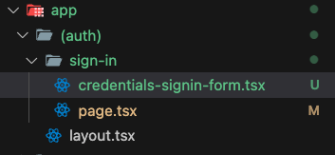

1. We also made the new default in the constants.

* And used it

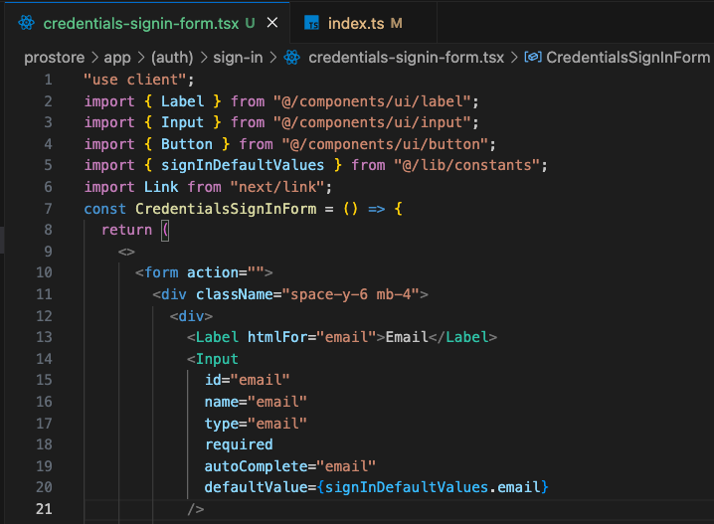

1. Now to make sign in work

* We first imported:

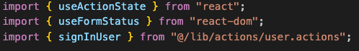

* Then we use the use action state hook for the sign in and use form status for making the user experience better and assigned the action to the form

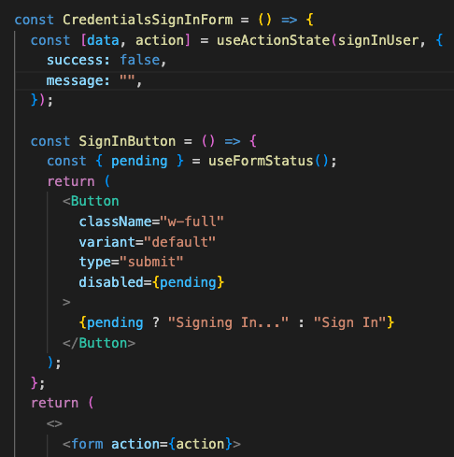

* Finally in the main parent, we checked if the session exists and redirect to the home page

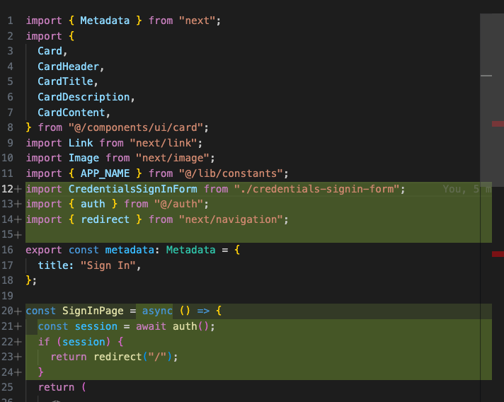

* Now with correct credentials we will be logged in setting the cookies and the sign-in route is now protected



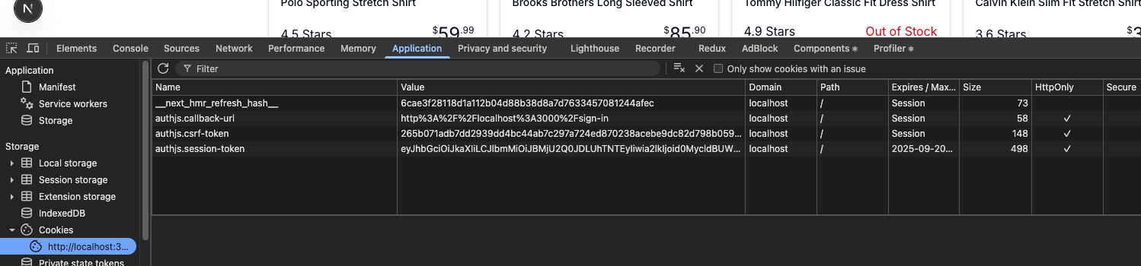

* We can also see the session using this route

